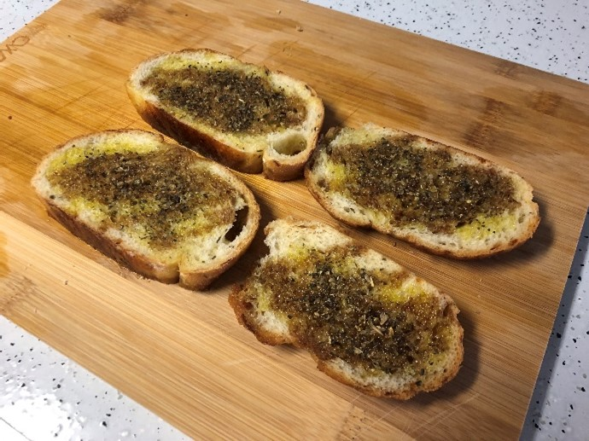
Ingredients
Lorem ipsum dolor sit amet, consectetur adipiscing elit, sed do eiusmod tempor incididunt ut labore et dolore magna aliqua. Ut enim avoluptate velit esse cillum dolore eu fugiat nulla pariatur. Excepteur sint occaecat cupidatat non proident, sunt in culpa qui officia deserunt mollit anim id est laborum.

Staple Foods:
Ingredient A
Ingredient B
Ingredient C
Fresh Produce:
Ingredient D
Ingredient E
Ingredient F
Ingredient G
Meat/Dairy:
- Ingredient H
- Ingredient I
- Ingredient J
- Spice/Seasonings:
Ingredient K
Ingredient L
Miscellaneous:
Ingredient M

Instructions
Nunc sed velit dignissim sodales ut. Amet nisl suscipit adipiscing bibendum est ultricies integer. Morbi non arcu risus quis varius. Vestibulum rhoncus est pellentesque elit ullamcorper dignissim cras.
Elit ullamcorper dignissim cras tincidunt lobortis. Amet dictum sit amet justo.
Nisi scelerisque eu ultrices vitae auctor eu.
This is text in the second column
Keep the instructions coming

[Note 1]
Here are some additional notes about cooking the dish. Whether this is something like additional ingredients, mastering a technique, or noting common mistakes, add these sections to clarify points that may be too long to include in the recipe.

[Note 2]
And you can just keep adding as many notes as you need.

